Firewall Rules Using UFW or iptables
Introduction
Firewalls are a fundamental component of modern network security, serving as the first line of defence between trusted systems and networks. They regulate incoming and outgoing traffic based on predefined security rules, ensuring that only legitimate connections are permitted while suspicious or unauthorized traffic is blocked. In the current threat landscape, where automated scans, intrusion attempts, and brute-force attacks occur continuously, a properly configured firewall plays a crucial role in protecting servers and endpoints from compromise.
This project focuses on implementing firewall rules on a Linux environment using either UFW (Uncomplicated Firewall) or iptables, two widely used tools for managing network filtering policies. The goal is to gain practical experience in designing, applying, and testing access control policies that selectively permit essential services such as SSH for remote administration and HTTP for web traffic while denying all unnecessary or risky connections. The project emphasizes the principle of least privilege, where only explicitly required ports are open, thereby reducing the attack surface of the system.
The process begins with setting safe default policies, followed by creating custom rules that allow only specific traffic. These configurations are then tested using tools like Nmap, which scans the target machine to verify whether the intended ports are accessible and unauthorized ports are blocked. Additionally, firewall logs are analysed to confirm that blocked connection attempts are recorded as expected, providing visibility into potential intrusion attempts.
The goal of this project is to understand and implement basic firewall configurations to control network traffic on a Linux system. By creating and testing custom rules using tools like UFW or iptables, we aim to allow only trusted connections (e.g., SSH, HTTP) while blocking unauthorized access. This project demonstrates how firewalls protect systems from unwanted network traffic and verifies the configuration using port scans and log analysis.

Abstract
This project demonstrates the practical implementation of firewall rules to secure a Linux system against unauthorized access. Using tools such as UFW or iptables, the firewall is configured to allow only essential services primarily SSH and HTTP while denying all other inbound connections by default. This selective filtering approach reduces the system’s exposure to common threats like automated port scans, brute-force login attempts, and exploitation of unused services.
The configuration process is followed by a verification phase using Nmap, a powerful network scanning tool, to confirm that only the intended ports remain open and that blocked services are inaccessible. Firewall logging is also enabled and reviewed to validate that denied connection attempts are properly recorded, providing valuable insight into potentially malicious activity.
This project matters because firewalls are a cornerstone of network security. Misconfigured or overly permissive rules can leave systems vulnerable, while overly restrictive settings may disrupt legitimate services. Learning how to design balanced firewall policies cultivates an understanding of real-world security trade-offs, where availability and protection must coexist.

Tools Used
Operating System:
1.Linux (Ubuntu/Debian)
- The core operating system (OS) that runs all the other software. Ubuntu is a popular, user-friendly distribution (distro) based on Debian.
- This is the "target" machine. It's the server you are trying to protect. You will install and configure the firewall on this machine.

- Why it was chosen:
  - Built-in Tools: It comes with ufw and iptables pre-installed or easily available, making setup quick.
  - Stability & Support: Debian-based systems are known for stability and have excellent online documentation and community support.
  - Package Management: The apt package manager (sudo apt install ...) makes installing additional tools like nmap and openssh-server extremely simple.
2.1Kali Linux / Parrot OS (Optional Testing VM)
- Specialized Linux distributions designed for security testing, penetration testing, and digital forensics. They come pre-loaded with hundreds of security tools.
- This is the "attacker" or "tester" machine. It exists in a separate virtual machine on the same virtual network. You use it to scan and attempt to access the Ubuntu server, simulating how a real hacker might probe your system.
- It provides a dedicated, safe, and legal environment to test your firewall rules from an external perspective, ensuring they work correctly against common attack tools.
Firewall Management Tools:
1.UFW (Uncomplicated Firewall)
A user-friendly frontend for iptables that simplifies firewall configuration using high-level commands.It is designed to make basic firewall management easy for everyday users and sysadmins without needing to know the complex syntax of iptables.
Key Characteristics:
- User-Friendly: Commands are simple, intuitive, and read like plain English.
- High-Level: You tell it what you want (e.g., "allow SSH"), not how to do it.
- Default Deny Policy: A security best practice. By default, UFW blocks all incoming connections and allows all outgoing. You then explicitly open only the ports you need.
- Profile-Based: Comes with application profiles (e.g., for Nginx, Apache, OpenSSH) to make opening ports for common services even easier.
2.1iptables (netfilter)
A command-line utility for configuring Linux kernel firewall rules at a low level, providing granular control.iptables is the standard, low-level command-line utility for configuring the Linux kernel's built-in netfilter firewall. It provides granular control over network traffic by defining rules that allow, block, or modify data packets.
Key Characteristics:
- Granular Control: Offers precise rule creation based on IP addresses, ports, protocols, and connection states.
- Kernel-Level: Operates directly at the operating system level for maximum performance and control.
- Complex Syntax: Requires in-depth knowledge to create and manage rules effectively, making it prone to configuration errors.
- Foundation: Serves as the underlying engine for many higher-level firewall tools.
Primary Use Case: Best suited for complex networking environments, routers, gateways, and scenarios requiring advanced packet filtering and network address translation (NAT).
Network Scanning and Testing Tools:
Nmap
Nmap (Network Mapper) is a powerful open-source command-line tool used to discover devices and services on a network, thereby creating a "map" of the network. It is essential for network inventory, security auditing, and identifying open ports.
Used to verify open and closed ports after applying firewall rules, detect filtered services, and validate that policies work as intended.
Hardware/Virtualization Requirements:
VirtualBox / VMware Workstation Player
- Hypervisor or virtualization software. It allows you to run multiple, isolated operating systems (called Virtual Machines or VMs) on a single physical computer (your laptop/desktop).
- This is the foundation that creates your safe, isolated lab environment.
- Why it's essential:
  - Safety: You can experiment with firewalls, networking, and even malware without any risk to your actual physical computer or your home network.
  - Isolation: You can create a virtual network where your "Ubuntu Server" VM and your "Kali Linux" VM can talk to each other, completely cut off from the internet and your real network.
  - Flexibility: You can take snapshots of your VMs. If you completely break the firewall configuration, you can revert to a previous snapshot in seconds.
Packages and Libraries:
1.ufw (Uncomplicated Firewall):
A user-friendly command-line tool that simplifies managing a firewall. It acts as an easy-to-use front-end for the complex iptables system. You use simple commands like ufw allow ssh instead of writing long, complicated rules. It's the recommended tool for basic host-based firewall management.
2.Iptables:
The powerful, low-level framework that is built directly into the Linux kernel. It is the actual engine that filters and controls all network traffic coming in and out of the system. While extremely powerful, its configuration is complex and difficult for beginners. ufw works by automatically generating iptables rules.
3.openssh-server:
A software package that provides the Secure Shell (SSH) service. Once installed, it allows this machine to accept incoming SSH connections, enabling secure remote login and command execution. A common firewall rule is to allow incoming SSH traffic so administrators can manage the server remotely.

4.nmap (Network Mapper):
A premier network discovery and security auditing tool. It is used to scan networks to find active devices and see what ports (services) are open on them. In this project, it is the primary tool for testing the firewall by scanning the machine to verify that only the intended ports (like SSH) are accessible.
5.iputils-ping:
A package that provides the essential ping command. ping is used to test basic network connectivity between two machines by sending small ICMP packets. It is useful for testing if the firewall is correctly blocking or allowing these specific types of network requests.

Steps involved in building the project
Step1 - Environment Setup
To install Kali Linux on a virtual machine (VM) using virtualization software. This creates a safe, isolated, and controllable lab environment where you can configure and test your firewall without any risk to your personal computer or network.
1. Download the Kali Linux ISO:
- Go to the official Kali Linux Downloads page.
2. Install Virtualization Software:
- Download and install Oracle VM VirtualBox (free) or VMware Workstation Player (free for personal use).
* Download VirtualBox
* Download VMware Workstation Player

3.Configure VM Networking (Crucial Step):
In your VM software's settings for the Kali machine, set the Network Adapter to "Bridged Adapter". Why Bridged Mode? This gives your Kali VM its own unique IP address on your local network, making it appear as a separate physical machine. This is essential so your host computer can scan it with Nmap and ping to test the firewall rules.
4. Start the VM and Take a Snapshot:
Boot up the Kali Linux virtual machine. The default credentials are usually kali / kali.
Your environment is now ready. You have a dedicated, safe, and updated Kali Linux machine where you can practice configuring ufw and iptables without any risk to your main computer.
Step 2 - Package Installation
To ensure all necessary tools are installed and up-to-date on your Kali Linux system.
Why this step is important: While Kali Linux comes pre-installed with many tools, it's crucial to:
- Update the system to get the latest security patches and software versions.
- Explicitly install ufw, as it is not included in the default Kali installation.
- Verify the presence of other critical tools like nmap and openssh-server.
1.Open a terminal – Run commands
Command: sudo apt update
- Purpose: Synchronizes the local list of available software packages with the online repositories.
- Function: This command checks for updates but does not install any software. It ensures the system has the latest information on package versions and dependencies before proceeding with an upgrade.
Command: sudo apt full-upgrade -y
- Purpose: Installs all available updates for installed packages.
- Function: This command downloads and installs all the updates identified by the previous apt update command. The -y flag automatically confirms the prompt to proceed, enabling unattended operation, which is essential for automated scripts and workflows.

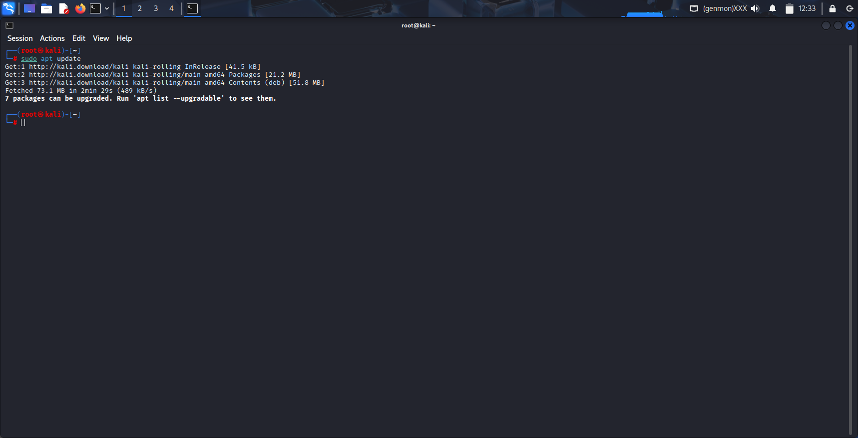
Fig. 1: Executing apt update on Kali Linux

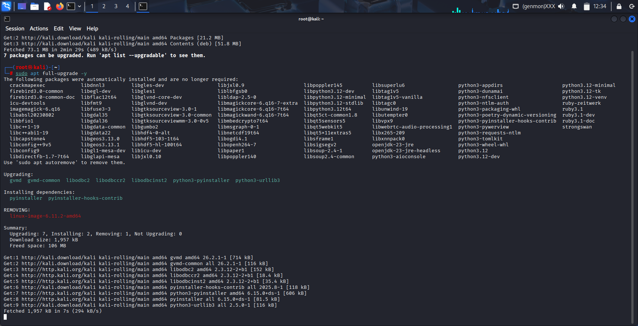
Fig. 2: Executing apt full-upgrade -y on Kali Linux
2. Install the Required Packages - Now, install the specific packages needed for this project:
- ufw: The Uncomplicated Firewall tool.
- openssh-server: To host an SSH service that we can allow through the firewall.

Command: sudo apt install ufw openssh-server -y
Purpose: This command installs two essential software packages on the Kali Linux system to enable remote management and basic security.
- Installing a firewall (ufw) to control network access.
- Installing an SSH server (openssh-server) to allow for secure remote administration.
Breakdown of Components:
- sudo: Executes the command with administrative privileges, which are required to install software.
- apt install: The package manager command to download and install software from the official repositories.
- ufw: The Uncomplicated Firewall package. This provides a user-friendly interface for managing the system's firewall rules, making it easy to control incoming and outgoing network traffic.
- openssh-server: The OpenSSH Server package. This enables the SSH (Secure Shell) protocol, allowing secure remote command-line login and other secure network services to the machine.
- -y: The "yes" flag. It automatically confirms the installation prompt, allowing the process to proceed without requiring manual user confirmation.

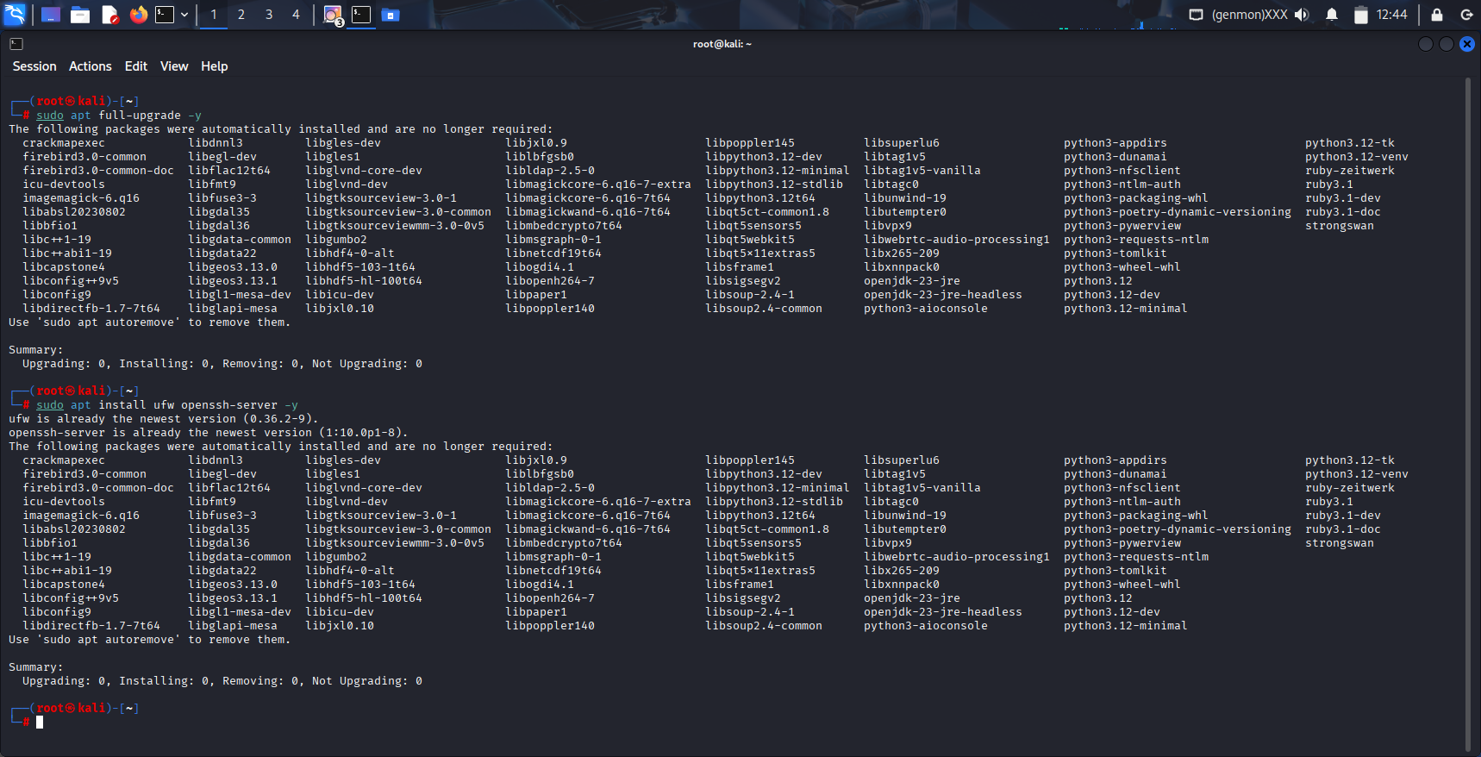
Fig. 3: Executing sudo apt install ufw openssh-server -y on Kali Linux

3.Verify the Installations
Command: sudo ufw version
To confirm that the Uncomplicated Firewall (UFW) software is installed and to check its version number.
Command: sudo systemctl status ssh
To check the current state (running or stopped) of the Secure Shell (SSH) service.
Command: nmap –version
To verify the installation of the Network Mapper (Nmap) tool and display its version details.

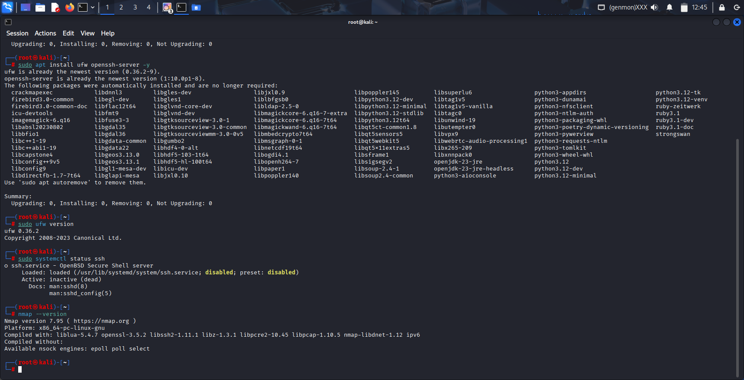
Fig. 4: Executing sudo ufw version, sudo systemctl status ssh, nmap –version on Kali Linux
Step 3 – Choose Your Firewall Management Tool
In this step, you decide whether to use UFW (Uncomplicated Firewall) or iptables for configuring your firewall rules. Both tools achieve the same goal but differ in complexity:
- UFW is a high-level frontend for iptables. It uses simple commands and is easier for beginners. A user-friendly command-line tool that simplifies managing a firewall. It acts as an easy-to-use front-end for the complex iptables system. You use simple commands like ufw allow ssh instead of writing long, complicated rules. It's the recommended tool for basic host-based firewall management.
- iptables is the low-level Linux firewall utility that gives full control but requires more detailed syntax. The powerful, low-level framework that is built directly into the Linux kernel. It is the actual engine that filters and controls all network traffic coming in and out of the system. While extremely powerful, its configuration is complex and difficult for beginners. ufw works by automatically generating iptables rules.
In this project, UFW (Uncomplicated Firewall) is selected because it simplifies firewall configuration using straightforward commands while still applying rules through Linux’s powerful iptables backend.
Verify UFW installation
Command: sudo ufw status
- To check the current operational state and active rules of the Uncomplicated Firewall (UFW).
- This command displays whether the firewall is active (enabled) or inactive (disabled). If active, it lists all configured rules that are currently controlling network traffic, showing which ports and services are explicitly allowed or denied.
- If you see Status: inactive, UFW is available and ready to use.

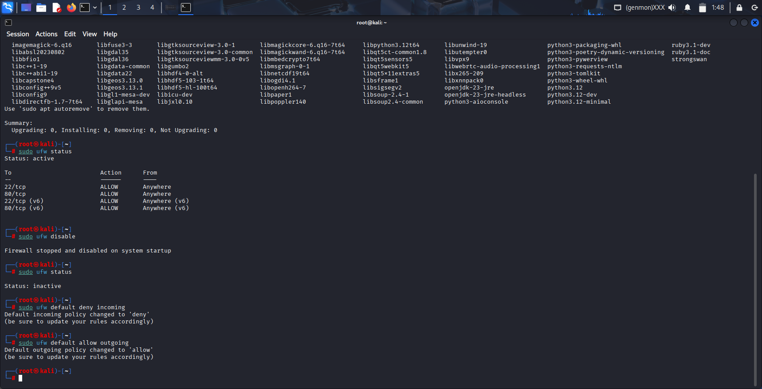
Fig. 5: Executing sudo ufw status on Kali Linux
If you see command not found, install it:
Command: sudo apt update
Command: sudo apt install ufw -y
Installs the Uncomplicated Firewall (UFW) software package.This command downloads and installs the UFW tool onto the system. The -y flag automatically confirms "yes" to the installation prompt, allowing it to proceed without manual intervention.

Command: sudo ufw default deny incoming
Sets a foundational security policy to block all incoming connections by default.This configures the firewall to automatically reject all incoming traffic attempts unless a specific rule is created to explicitly allow it.
It configures the firewall to block all incoming connections (e.g., connection attempts from other computers, hackers, or scanners) by default.


Fig. 6: Executing sudo ufw default deny incoming on Kali Linux
Command: sudo ufw default allow outgoing
This command allows all traffic originating from your Kali machine to go out to the network. This is necessary for your system to function normally (e.g., to browse the web, update packages, or download files).


Fig. 7: Executing sudo ufw default allow outgoing on Kali Linux
Step 4 – Configure Baseline Firewall Rules Using UFW
This step sets up the actual firewall policy on your system. The goal is to block all unwanted traffic by default and allow only specific, trusted services such as SSH and HTTP. This ensures your system is secure while remaining functional.
Allow SSH (Secure Shell) Traffic: SSH is used for secure remote command-line access and administration of your Kali Linux machine. Allowing it is crucial for remote management.
Command: sudo ufw allow ssh
This command configures the system's firewall to permit incoming Secure Shell (SSH) connections.
It opens the standard network port (port 22) used for SSH, enabling secure remote login and administration of the server from another computer on the network.
Alternative Command (by port number): sudo ufw allow 22/tcp
This creates a rule that tells the firewall: "Accept all incoming TCP connections on port 22."

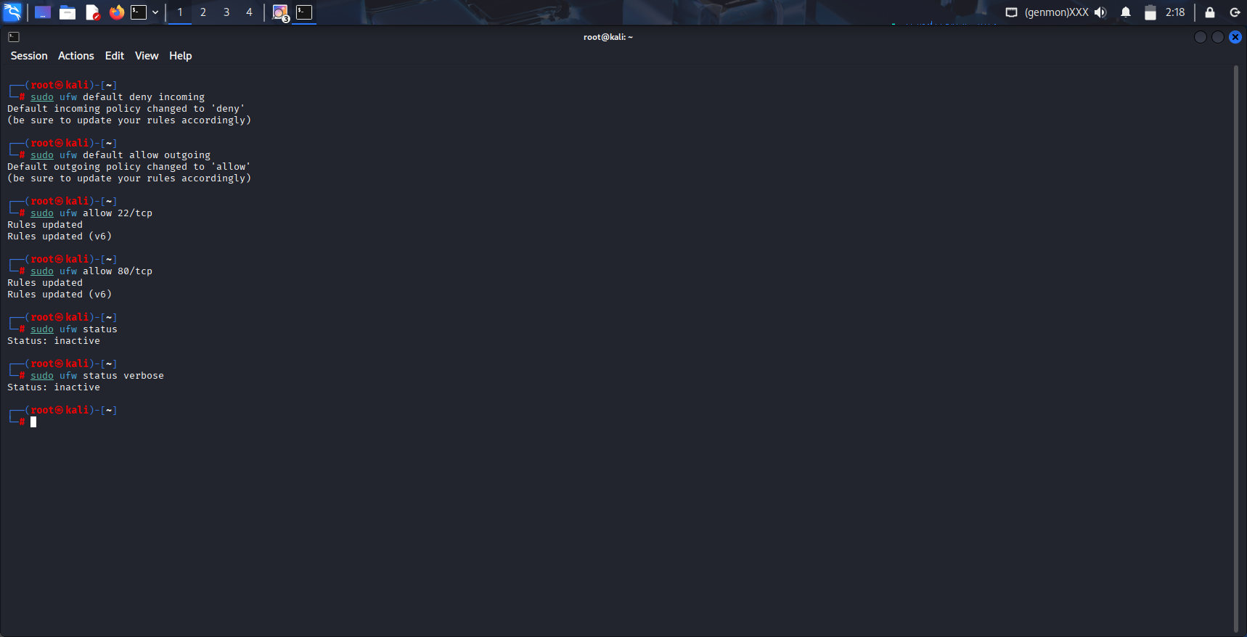
Fig. 8: Executing sudo ufw allow 22/tcp on Kali Linux
Allow HTTP (Hypertext Transfer Protocol) Traffic: This is to allow traffic to a web server (like Apache or Nginx) if you were hosting a website. It's a common service to practice securing.
Command: sudo ufw allow 80/tcp
This command configures the system's firewall to permit incoming HTTP traffic.It creates a rule in the Uncomplicated Firewall (UFW) that allows external devices to establish TCP connections to this machine on port 80. Port 80 is the standard network port used for unencrypted web traffic (HTTP).

Fig. 9: Executing sudo ufw allow 80/tcp
Verify the Rules Were Added Correctly:
Command: sudo ufw status
- Before enabling the firewall, it's good practice to check that your rules are in the queue as expected.


Fig. 10: Executing sudo ufw status and the output is inactive

Step 5: Enable the Firewall
To activate the UFW firewall with the configured default policies and allow rules, making them actively enforce network traffic control on your Kali Linux system.
1.Final Pre-Activation Check:
Command: sudo ufw status verbose
- This is your last chance to review the rules you've configured before they become active. It ensures you haven't made a mistake (like forgetting to allow SSH).
- Expected Output (Before Enabling): Status: inactive


Fig. 11: Executing sudo ufw status verbose and the output is inactive
2. Enable the Firewall:
Command: sudo ufw enable
- To activate the Uncomplicated Firewall (UFW) and start enforcing its configured rules.
This command loads the predefined firewall rules into the system's netfilter framework and sets the firewall to start automatically upon system boot.
- Once enabled, all incoming and outgoing network traffic is filtered according to the rule set. By default, this typically means all incoming connections are blocked except for those explicitly allowed, while all outgoing connections are permitted.

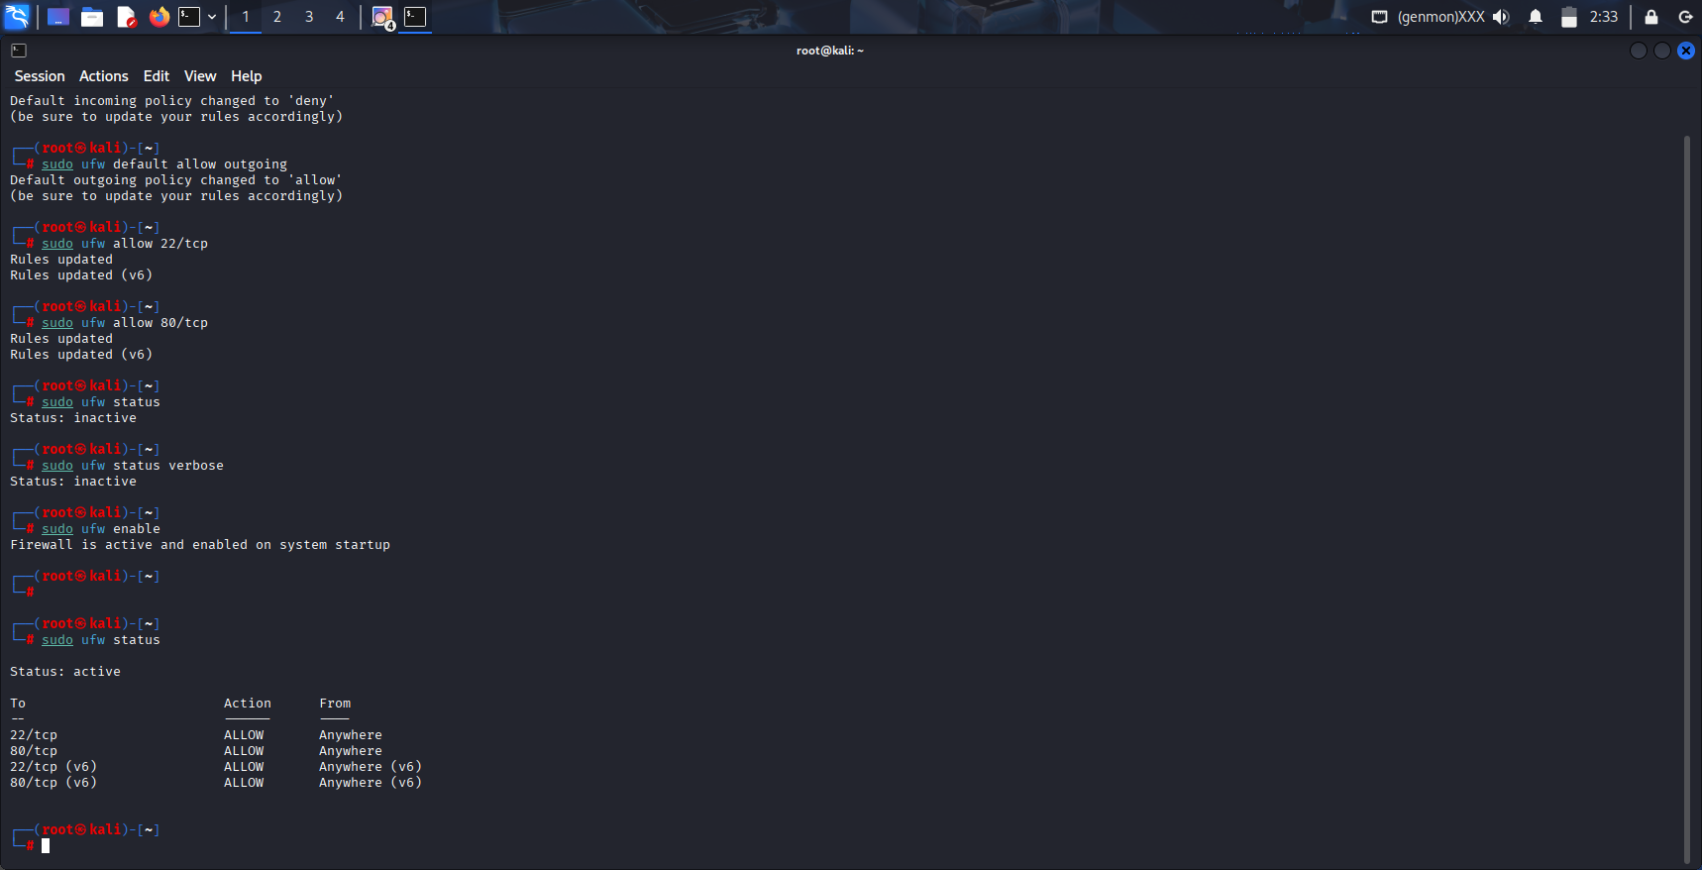
Fig. 12: Executing sudo ufw enable
- Expected Output & Prompt: Command may disrupt existing ssh connections. Proceed with operation (y|n)?
- Action: Type y and press Enter.
- Final Output: Firewall is active and enabled on system startup

3.Verify the Firewall is Active and Rules are Enforced:
Command: sudo ufw status verbose
- Run the status command one final time to confirm the firewall is now running.
- Expected Output (After Enabling):The status is now Status: active. This confirms the firewall is now actively blocking and allowing traffic based on your rule set.
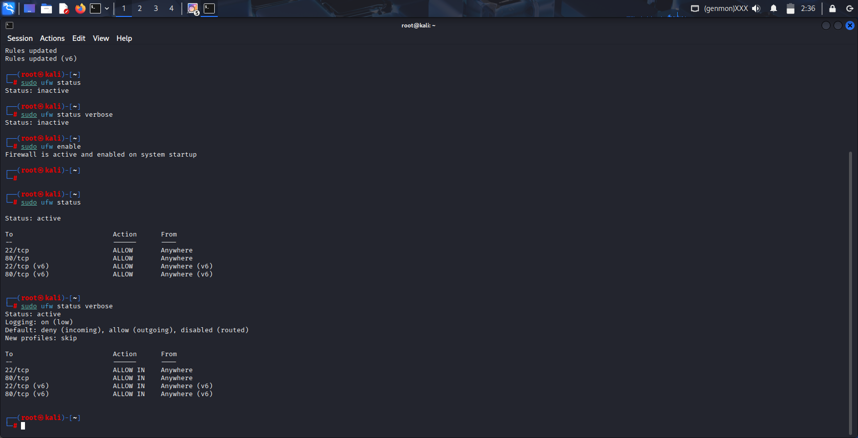
Fig. 13: Executing sudo ufw status verbose to verify firewall is active and rules are enforced
Step 6: Test the Configuration
To verify that the UFW firewall rules are working correctly by testing both the allow rules (SSH, HTTP) and the default deny policy for all other traffic. This proves the effectiveness of configuration.
Find Your Kali Linux VM's IP Address
Command on Kali Linux: ip a
- You need to know the IP address of your Kali machine to target it with tests.
- Look for your active network interface (like eth0 or ens33) and note the ip address (e.g., 192.168.1.15). This is your target IP.

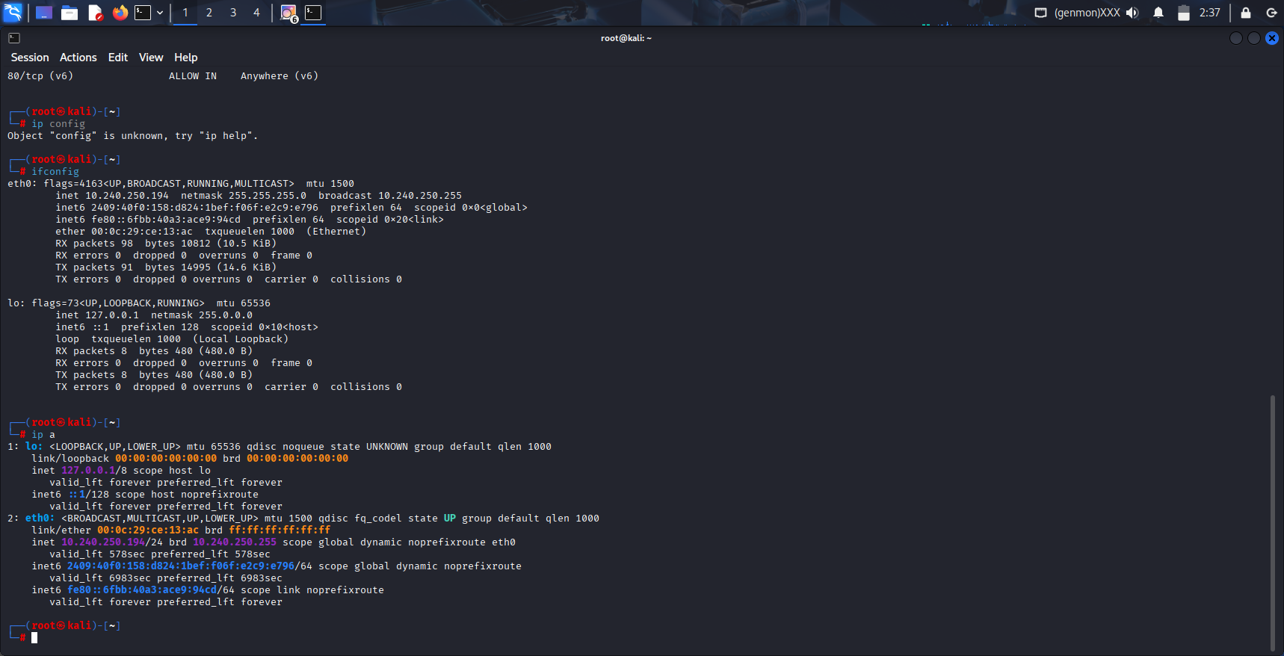
Fig. 14: Checking ip a

Test 1: Test Allowed Services (The "Whitelist")
Test SSH (Port 22) with Nmap:
To confirm that the sudo ufw allow ssh rule is working and the port is open to the world.
Command: nmap -p 22 <Kali-VM-IP-Address>
Expected Result: The output should show port 80 as open.

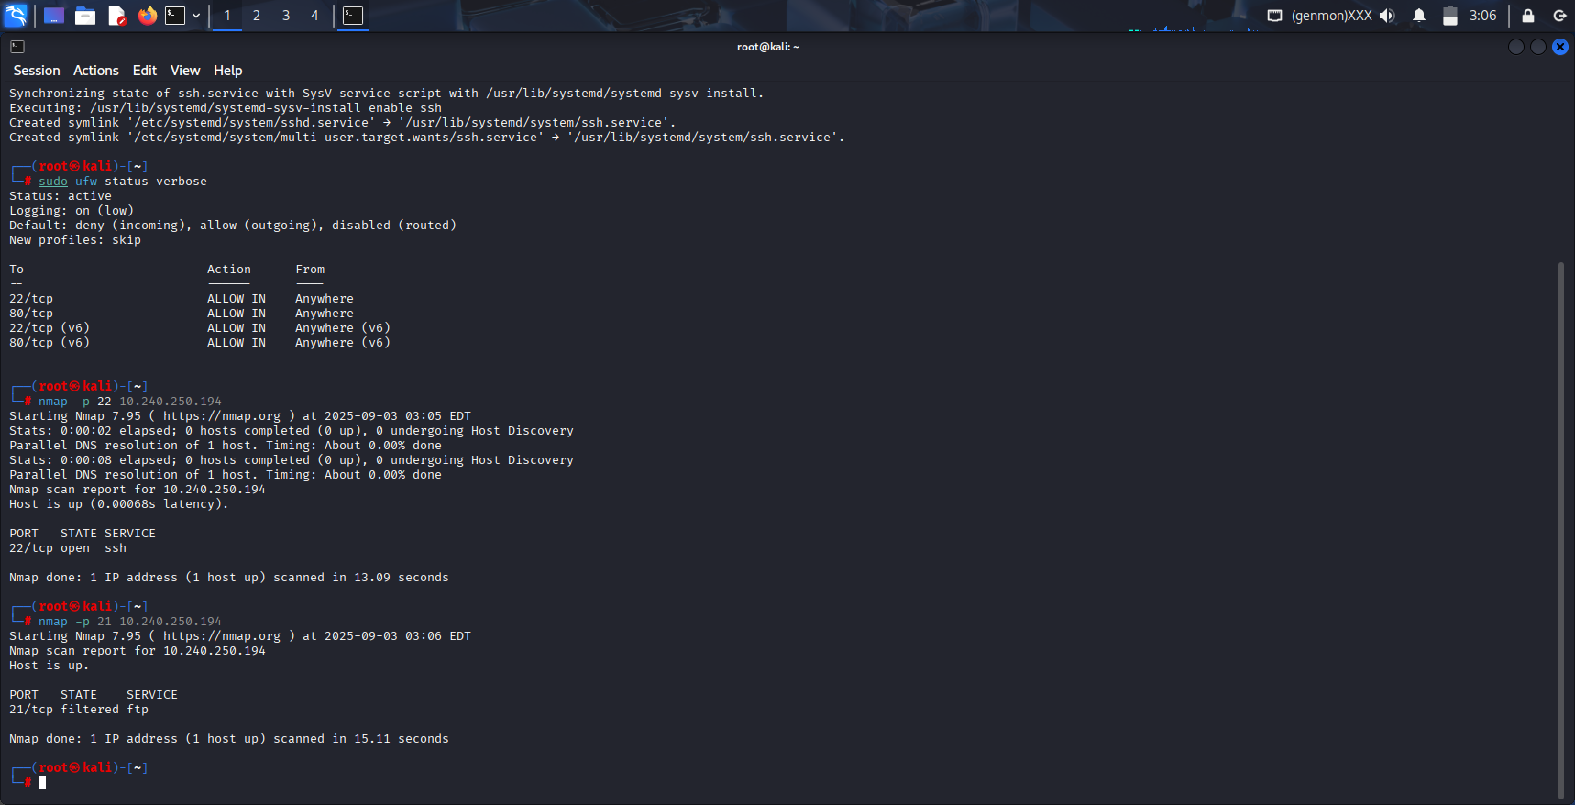
Fig. 15: Firewall is c allowing incoming TCP connections on port 80.
It means the firewall is correctly allowing incoming TCP connections on port 80.
Test 2: Test Denied Traffic (The "Default Deny" Policy)
1.Test a Blocked Port with Nmap:
To confirm the default deny incoming policy is working for services you did not whitelist.
Scan a common port that you did not allow, such as port 21 (FTP), 23 (Telnet), or 443 (HTTPS).
Command: nmap -p 21 <Kali-VM-IP-Address>
Expected Result: The output will show the port's state as filtered. This is the key result.

Fig. 16: Firewall is c allowing incoming TCP connections on port 21
Filtered means Nmap can see that a host is at the IP address, but it receives no response from the port. This is exactly what a firewall doing its job looks like—it is silently dropping the packets, making the port appear "stealth" or filtered.
2. Test ICMP Blocking (Ping):
UFW's default deny incoming policy also blocks ICMP echo requests ("pings"), a common network probing tool.
Command: ping <Kali-VM-IP-Address>
Expected Result: The ping requests will time out or show "Request timed out" (on Windows). You will see no reply from the Kali VM.
It means firewall is successfully blocking all unsolicited incoming traffic, even basic pings, which is a common security hardening technique.

Conclusion
This project successfully demonstrated the practical implementation of a host-based firewall on a Kali Linux system using Uncomplicated Firewall (UFW). The core objective was to enforce the principle of least privilege at the network level by establishing a default-deny inbound policy and creating explicit allow rules for essential services—SSH (port 22) and HTTP (port 80). The configuration's effectiveness was rigorously validated through testing with nmap and ping, which confirmed that authorized traffic was permitted while unauthorized access attempts were systematically blocked.
Summary of Accomplishments:
- Configured Secure Defaults: Set UFW to deny all incoming and allow all outgoing traffic, creating a secure baseline.
- Created Whitelist Rules: Implemented targeted allow rules for SSH and HTTP, ensuring necessary functionality while minimizing the attack surface.
- Verified Configuration: Activated the firewall and confirmed the rules were loaded correctly using sudo ufw status verbose.
- Tested Effectiveness: Proven through empirical testing that:
  - Ports 22 and 80 responded as open to scans.
  - Unauthorized ports (e.g., port 21) were reported as filtered.
  - ICMP echo requests (pings) were blocked, resulting in timeouts.
Key Learnings:
- Fundamental Security Principle: The critical importance of a default-deny firewall posture as a first line of defence in securing any network-connected device.
- Practical Tool Proficiency: Gained hands-on experience with UFW as a user-friendly abstraction for the more complex iptables framework, streamlining firewall management.
- Validation is Mandatory: Understanding that configuration alone is insufficient; testing with tools like Nmap is essential to empirically verify security controls are working as intended.
- Attack Surface Reduction: Learned how closing unnecessary ports drastically reduces the number of vectors available to an attacker, a core concept in system hardening.
- Operational Awareness: The project highlighted the careful balance required between security and accessibility, such as the need to allow SSH before enabling the firewall to prevent locking oneself out.
In conclusion, this project provided invaluable, hands-on insight into fundamental network security practices. The skills developed—configuring, managing, and validating a firewall—are directly applicable to real-world roles in system administration, network security, and cybersecurity auditing.

